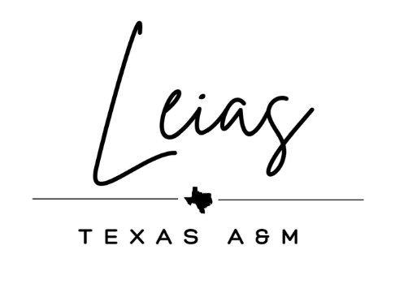
2024 Spring LEIAS Application

Thank you for your interest in LEIAS! We are so excited to get to know you all through this application process. Please make sure to complete this application fully while following all instructions.

Applications must be typed and submitted in PDF form to leias.vicepresident@gmail.com and president.leias@gmail.com by Tuesday, February 6th, 2023 by NOON.

To turn in your application, make a copy of this document and submit it as a PDF along with the following requirements.

Please make sure to complete the following in its entirety:
- Attach a copy of your resume.
- Facts sheet.
- Get to know me sheet
- Short answer and essay questions sheet
- Include a photo of yourself. Just something you can be identified with - doesn’t have to be too fancy!

Your application in total should not be more than six pages not including this page and the title page.

If you have any questions regarding the application please contact leias.vicepresident@gmail.com or DM us on Instagram @tamuleias.

Facts Sheet

(Insert a picture of you here)

Name: ______________________________________________

UIN: ________________________________________________

Classification: ________________________________________

Expected Graduation:__________________________________

Major: ______________________________________________

Email: ______________________________________________

Cell Number: ________________________________________

Are you in good academic standing with the university (GPA 2.0 or above)?
Yes _______
No _______

Are you in any other organizations? If so, please list them below.

_____________________________________________________

______________________________________________________

Would you be available to attend bi-weekly meetings on Wednesday evenings?
Yes _______
No _______

Get to know me!
Must be answered in 1-2 sentences max

- Show us your sense of humor, insert your favorite meme here!
- If you were stranded on a deserted island, what three things would you want to have with you?
- What’s something on your bucket list that you haven’t done yet?
- What’s a small thing that never fails to make you happy?
- Do you have a favorite quote or motto?

Short Answer Questions
Must be answered in 3-4 sentences minimum

- What/who motivates you to be a strong female leader?
- Explain three qualities you would bring to our organization.
- Our philanthropy is Urgent Animals of Hearne. Why do you believe animal rescue is an important cause?
- What are you looking to gain from joining our women's organization? In your opinion, what separates LEIAS from other organizations?
- Tell us about a time you had to resolve a conflict with a peer/friend and how did you approach the situation?

Essay Question
Must be answered in 8-10 sentences minimum

- Narrate a moment of personal growth that stands as a defining chapter in your life story. How did this experience shape your pursuit of knowledge, empathy, and personal betterment?

